Goon Report: Optimal angle of gooning given a desired distance

Radu Banica; 29.05.2025

University of Southern Denmark, Sønderborg.

1. Objectives

Given that the Gturret has to spray water at specific locations while also remaining stationary, we have to use projectile physics and subsequent angles to our advantage. The objective is to find either a formula or a table of values that takes in the position of the target as input and outputs the desired angles for the 2 axes of the motors.

1. Theoretical Calculations

A. Inspiration

During Dynamics, our teacher, Bjarne, presented a problem with an object being flung at a specific exit velocity, angle and displacement.[1] He presented two formulas split into X and Y axis. Both formulas are dependent on time, however by using the properties of gravity we can calculate the time needed for the object to impact the ground. By using this time, we can input it into the X axis equation to calculate the distance travelled by the object. I took this idea and later also modified it to fit the needs of the project.

B. Finding the exit velocity

In order to use Bjarne’s formula, we had to find the exit velocity of the pressure tank. We scratched our heads trying to think of a formula, however we gave up and decided to ask ChatGPT. We knew the pressure inside the water tank and the diameter of the tube where the water was to come out off. The response from ChatGPT was the Bernoulli formula.[2] We went to check with Bjarne if this formula was a result of Artificial Intelligence Schizophrenia or an actual existing formula. Bjarne confirmed this formula from the fluid dynamics book. Replacing the following constants with our actual pressure inside the tank and the pressure of the atmosphere. We aim for the inside pressure to be around 50 PSI, however this needs to be converted to SI units into Pascal.

Image 1; ChatGPT response showing Bernoulli’s formula for exit velocity.

The result is 22 meters per second. I highly suspected that the actual velocity would be significantly lower due to loses from air resistance and from the sticky qualities of water making it more unpredictable.

Image 2; The calculation on paper.

C. Finding the theoretical maximum

Firstly, I went into the class intended for the use of our turret, U102. We first took some measurements as can be seen bellow. Finding the overall size of the classroom and more importantly the positions and displacement between the chairs.

We selected the furthest possible chair from the turret, which was in the bottom left corner of the class. The calculations, again, are shown below for the distance, which turned out to be 4.3 meters away using Pythagoras’ theorem. Despite this, we set the hard goal at 5 meters minimum, jut to be sure.

For later reference, the vertical plain in the drawing is referred to as the “row” and the horizontal to as the “chair”.  
  
We then tested the aforementioned minimum distance with the formula from the dynamics class. We placed in the exit velocity of 22 meters per second with an angle of 45 degrees, as it allows for the longest parabolic and we took displacement as 0 because the teacher’s table, on which the turret sits, is not any taller than that of the students. First, we solve for the Y axis part of the equation as it is a parabolic and it has two x intercepts, one at t = 0 and another one when the water impacts the surface. Separating for the time gives us the time of flight of our projectile. To solve for t, we notice that the equation looks like a quadratic allowing us to use the quadratic formula.

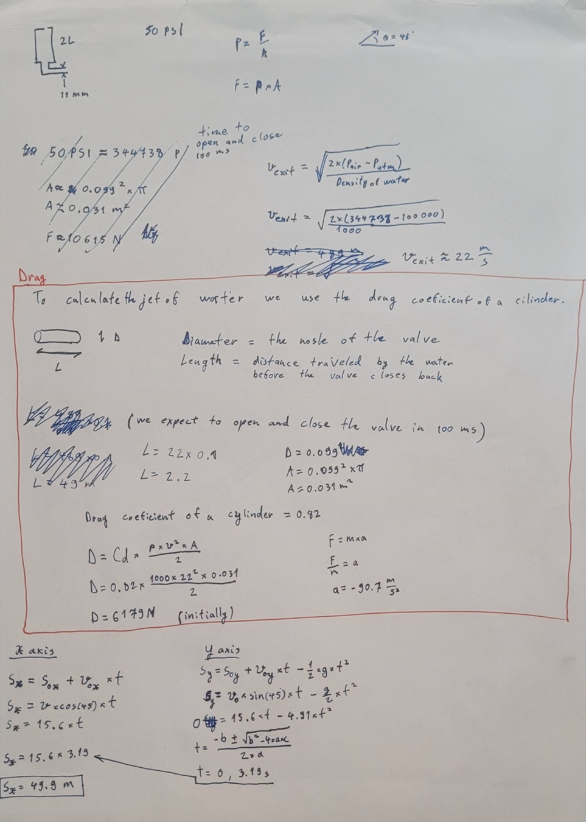

We get two values, as expected. We choose the nonzero value for the t to input it into the X axis formula. This is a simple linear equation that gives us the maximum distance of around 50 meters, which, for some reason, I doubt that will correspond with reality. I expect the error in this calculation comes from the previous error in calculating the exit velocity. Air drag, as I have been informed by the teachers, is negligible in respect to water streams, as water develops a very aerodynamic shape while in flight. Despite all this, the theoretical calculations confirm that the projectile will travel more than 5 meters.

III. Descent into madness

A. Coordinates

In order to begin even considering making a formula for the angles, we need to define the classroom into a grid system and converting all the locations of the seats into sets of distances on said grid. We took the turret as the origin of said graph. The y represents the chairs and the x represents the rows.

The calculations for the position of chairs on the grid was quite boring, but here it is below.

In short it is just linear algebra that converts the “row” and “chair” into a metric displacement on the x and y axis.

B. X axis angle

Using Pythagoras’ theorem, we placed the x and y axis displacement to get a total distance from the target to the turret. This is because the x and y axis displacements act like the opposite and adjacent side of a larger triangle starting from the turret and ending at the target.

We can also use this triangular identity to find the angle at which the turret would have to turn to face the target. Knowing that the opposite side of this triangle is the y axis displacement, and the adjacent side is the x axis we can also find the angle using the inverse tangent.

Afterwords we replace the y and the x in the equation with the linear equations to get an equation for the angle of the X axis motor given the chair and row.

This was relatively easy, from here, the real pain begins.

C. Y axis angle

Unlike the X axis angle for the motor, the Y axis angle must account for the trajectory of the water to the target. This is not the hard part since we already had an equation for the distance travelled of just such a projectile. In Bjarne’s equation we have the angle and exit velocity as inputs and the distance travelled as outputs. This is suboptimal as we want the angle to be the output of the equation with the distance travelled being the variable.

To begin finding the angle, we must first get an equation in the desired form described in the previous paragraph. We have 2 equations: x and y, and 3 unknowns: distance travelled, the Y axis angle and time. We can merge the two equations getting rid of 1 unknown in the process. Here we chose to get rid of the time, as we are not interested in finding out anything about it in our project.

The image below is me writing the aforementioned, on paper, at 2 or 3 AM in the morning while talking online to a friend that studies at DTU.

We then had an equation of the distance travelled with respect to the angle by substituting the time in both equations. The rest of the variables are constants of which their importance will be later stated. All that is needed to do now is to invert the function such that the angle is a function of distance, simple!

C. The inversion

We copied the function into Maple. We then ask maple to solve the function for the angle.

The result given by Maple is pure schizophrenia. This is because the angle is in fact not a linear function of distance and neither should it be negative nor have a negative regression.

Perhaps this was the wrong command. After asking the friend at DTU with more experience in Maple for all the possible prompts, this was the result.

A lot of brute force with a lot less success. At the same time, he was also trying to brute force it as well.

At last, it looked like we had a function. That being the last function visible in the picture above. It took in the distance as an input and resulted in an angle as an output. We tested it a few times to see if the angles looked appeared plausible, and they did. The next morning the function was tested on the Arduino. Only to realise, mid typing, that the function from Maple was also schizophrenic. Observe the picture below.



For some unknown reason this function had a comma. This is not a mathematical sign and neither does it exist in the Math library on the Arduino. So, we had to go back to the drawing board.

While repeatedly slamming the head against the table, the original function for the distance was being analysed on Maple and on paper and even on the internet. We went on internet forums with mathematicians, asked the Math teacher here at the university as well as Bjarne and, despite their best attempts, none were able to inverse the function. It was suggested from most of the aforementioned sources that a table of values would serve the purpose. This would involve running the equation with multiple different inputs to record the outputs. This data would then be compared in the Arduino to match the distance needed with the closest possible candidate in the table that would be linked to an angle.

This solution was considered and promptly rejected. The reason for the rejection was not due to the possible inaccuracies that may come from the table method, as an approximation for the angle was acceptable in our case. It was rejected due to the need to the need to remake a new table each time one of the constants in the equation had changed. This would include displacement of the turret in elevation or position on the table and the exit velocity. The exit velocity was especially consequential in this decision as, at the time, we did not know whether we were going to use a pressure tank or an electric pump to expel the water. Both having differing exit velocities. Creating a table of values would be simple in the short term but it could come back to hunt us in the long term in case we wanted to make modifications to the turret.

After a lot of time was spent on analysing the equation and slamming the head against the table. An Ureka moment was reached once looking at the graph of said function.

Notice how, despite the function being a product of both sine and cosine functions, it still results in a graph that has the shape of a sine function with a modified amplitude and period. Meaning that we could write it as a function where the C is the amplitude, and the K is the period constant. We can deduct from the graph that it repeats itself twice every two pi meaning that . We can also deduce from the graph that the amplitude is the value at which is the maximum. This also aligns with the hypothesis that the greatest distance travelled by a projectile is at 45 degrees. Finding the value at 45 degrees is just substituting into the original function to get the constant .

This is the new equation which is a lot simpler to invert because it only contains a function of sin inside. We know this because this is how the precious attempts to solve this function by hand using trigonometric identities looked like. An equation only a mother could love.

Back to the promising function, here it is graphed on the same graph as the original function.

It is a perfect match. A random angle value was taken to compare the results of both functions, and they were identical. The function was then inverted in Maple and converted from radians to degrees to give us the following.

The graph given has one y value for the x. The arcsine graph only goes to 45 degrees. This is not an issue, as we do not need any greater angles since they would result into repeating distances. It, in fact, saved us from having to code in a selection to choose the lowest positive angle.

D. The constants

Remember how, in the last paragraph of the B section it was mentioned that the constants are important. Here they are. The distance has been replaced with the previously found Pythagoras’ theorem and the amplitude is expanded to include all the previous constants. This is the absolute formula, flexible to any change in our project.

And bellow is the simplified formula for use in the code once all the constants are added. This is for ease of implementation into programming for the short term.

IV. Results

A. Testing

After testing the turret with the code, it became apparent that the angles for the Y axis were almost always approximated to 0 degrees. At first it was thought that the reason for this was the large exit velocity calculated previously resulting in the angles being way smaller. The error here would result from the theoretical exit velocity being too high. A fix to this would be simple as it would only be needed to test the distance the water travels in real life at a given angle or displacement above the ground. From there we have all the variables except the exit velocity which can be found by plugging it into one of the distance or angle formulas stated in previous chapters.

The issue might in fact not be the exit velocity however, but the way the equation was simplified. Bellow this paragraph is an equation that is derived from the original inversion. Despite both this formula and the previous formula that was tested originating from the same constants. Manually replacing the values for the constants in the absolute formula and testing for the same position, results in a difference in angle across the two formulas.[3]

The formula above, for some reason, results in more believable angles than the absolute formula. This remains a mystery to us to this day. However, it has taught us that more rigorous testing is needed at every step of the way before calling a part of the project completed as it may cause severe problems down the line.

1. Newton said that the forces can be split into multiple perpendicular axis.
2. ChatGPT.
3. A screenshot of a math problem

   AI-generated content may be incorrect. notice how the 3 values above do not match with the 3 values below.